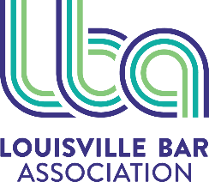

2025 Bar Briefs Editorial Calendar

Month | Theme
January | LBA Year in Review
February | Public Interest / Solo, Small Practice
March | Criminal Law / Appellate Law
April | Environmental Law / Tort & Insurance Law
May | Corporate Law / Federal Practice
June | Litigation / ADR, Mediation
July | Family Law / Probate & Estate Law
August | Taxation / Bankruptcy
September | Law Schools / Young Lawyers
October | Labor & Employment / Real Estate / Administrative Law
November | Health Care Law / Human Rights
December | AI, IP, Privacy Law / In-house

The Louisville Bar Association appreciates the contributions of its volunteer writers.

Individuals interested in submitting articles, reprints, announcements and creative pieces for consideration in Bar Briefs, may do so by emailing Kim Kasey at kkasey@loubar.org.

